Repayment Basics
Residents are required to report changes in employment, household composition, and income increases of $200 or more per month to Owner/Agents (O/As) in a timely manner. Although HUD does not specifically define “timely manner,” each property should detail within their House Rules what constitutes late reporting and/or failure to report.

Repayment Agreements are necessary when an O/A discovers that a household has received an overpayment of assistance and did not report it in a timely manner. This discovery can come as a result of many different types of information – including tips from other community members, data from required Enterprise Income Verification (EIV) reports, and even recertification interviews or forms from the resident themselves.

Once the O/A confirms that the resident(s) misreported their income, the household is responsible for returning the overpaid funds to HUD. If the household is unable to pay all of what is due in a lump sum, the household may enter into a Repayment Agreement with the property to return the funds owed to HUD in scheduled increments.

This Guide was created to help O/As determine what steps to take to successfully set up a Repayment Agreement with a tenant, to report it properly to HUD, and to provide direction to other helpful resources to get the funds repaid to HUD.

Common Terms Defined
Wash Adjustment – Positive amount which cancels out the negative adjustments created by the certifications submitted as a result of unreported income. This is the total amount the resident owes HUD.
Installment Payments – The payments the resident has agreed to make each month to return the overpaid assistance to HUD.
Overpayment Timeframe – The beginning and ending date of overpaid assistance.
Collection Expenses – Expenses incurred by the O/A in creating the repayment agreement or attempting to collect payments from the resident. Examples include staff time spent verifying and documenting unreported income, collection agency fees, etc. The O/A must document these expenses for review.

New Repayment Agreements
This section of the Guide describes what to do when setting up a previously unreported Repayment Agreement. More information about Repayment Agreements is available in HUD’s MAT User Guide Version 2.0.2.D, Chapter 4, Section 4.9.

Step 1: Calculate the Overpaid Assistance
- Work with the resident to determine the timeframe that subsidy was overpaid and to create corrected or new certifications that reflect the proper income. When a resident does not report changes in a timely manner, they lose their right to a 30-day notice of rent increase. See HUD Handbook 4350.3, Chapter 7, Section 7-8.D.2 and D.3 to determine the effective date of changes in rent. Also note that per Chapter 8, Section 8-21.A.5, the overpayment timeframe cannot exceed 5 years.
- After you’ve created the necessary certifications, you need to calculate the total amount the resident owes to HUD. The attached spreadsheet named SHCC Repayment Calculations has been created to help you determine what the total amount of overpayment should be. See below for instructions on how to use the spreadsheet. Create a Repayment Agreement with the household, which must include the following:
  - Total Retroactive rent balance owed.
  - Lump sum paid at the time of execution (if any).
  - Monthly installment payment amount. (See HUD Handbook 4350.3, Chapter 8, Section 8-23.A for help in calculating this amount.)
  - Statement that residents who do not agree to repay these funds will be in non-compliance and may be subject to termination of tenancy. This should reference the applicable HUD Model Lease paragraph.
  - Statement that the installment amount will be renegotiated if the household’s income increases or decreases by $200 or more per month.
  - Statement that the installment payment is in addition to the family’s monthly rent payment and is payable to the O/A.
  - Statement that late and missed payments constitute default of the agreement and may result in termination of tenancy.
- The Head of Household and O/A must sign and date the new certifications, as well as the Repayment Agreement. It’s recommended that you also have the Repayment Agreement signed by the household member who was responsible for the unreported income.
Step 2: Report the Repayment Agreement on the Next Voucher
Specific instructions for how to post these items to your voucher should come from your Software Vendor. They will be able to tell you exactly how to properly report the Repayment to the voucher. The voucher reporting requirements for vendors are located in HUD’s MAT User Guide Version 2.0.2.D, Chapter 6, Section 6.8.

With the next voucher submission, you must include:
- Error-free certifications to support the corrected HAP and rent amounts. Note – these certifications should produce negative adjustments for the unit in the Adjustments to Schedule of Tenant Assistance Payments Due (HUD Form 52670-A Part 3) page of the voucher.
- The Wash Adjustment on the Repayment Agreements for Schedule of Tenant Assistance Payments Due page of the voucher (HUD Form 52670-A Part 6, typically the very last page of the printed voucher).
- If the household made a Lump Sum payment, report that amount as a negative amount on the same page, as well.
- Email a copy of the signed Repayment Agreement and the completed SHCC Repayment Calculations spreadsheet or your own detailed breakdown of how you came to the Wash Adjustment total to your TRACS Data Analyst. Although the spreadsheet is not a requirement, SHCC must deny the Wash Adjustment in instances where we cannot determine how the total amount is calculated, so it’s in your best interest to provide as much detail as you can.
Step 3: What if the Wash Adjustment was Denied?
SHCC cannot approve a positive Wash Adjustment unless we agree on the total amount due from the household. When we receive a new Repayment Agreement on the voucher, we review the tenant data we have received to determine whether it supports the total Wash Adjustment amount.

It’s very important for O/As to be able to provide detailed information to their TRACS Data Analyst on the timeframe of overpayment and specific calculations that were used to come up with the total Wash Adjustment. In many cases, the Wash Adjustment was denied because one or more certifications is missing or has received a fatal TRACS error, which results in the negative adjustments not appearing on SHCC’s approved version of the voucher.

When you receive your monthly Voucher Reconciliation Email from SHCC, review the Tenant Repayment Agreement - Payments report, which displays any denied agreements in a separate section of the report. Then review the tenant data files that you have transmitted against the adjustments displaying on the Voucher Report. If the negative adjustments didn’t post (in full or in part), it’s very likely that the certifications were not received or have fatal errors. You can review any fatal errors in the TRACS Error Response files that are sent through iMAX. Most software vendors have a report available to view that will help display this information.

The Final Step: Resident Payments Toward Existing Repayment Agreements
Once the Repayment Agreement has been approved by SHCC and the resident makes scheduled payments, you need to post them to the voucher on HUD Form 52670-A Part 6.
If the resident is making payments for multiple agreements, you must submit multiple Repayment Agreement records (i.e., the payments will display on separate lines).

The Total Payment field should include the amount collected this month. If the O/A has incurred expenses for tracking/collecting the payment, you can keep up to 20% of the total amount the resident paid to cover those costs. See HUD Handbook 4350.3, Chapter 8 Section 8-21.B.2 for further information.

The Amount Requested field should include the total amount the resident paid this month less allowed collection expenses per handbook guidance.

How to Use the SHCC Repayment Calculations Spreadsheet
This spreadsheet is designed to help O/As calculate the total Repayment Agreement amount, and to help SHCC more easily review and approve them. Please note that this spreadsheet is meant to calculate the total amount owed to HUD, so if there were also incorrect calculations made by the property or if the O/A didn’t provide the proper notices, you will need to separately calculate those amounts and subtract that from the total amount owed. You must communicate this to your TRACS Data Analyst so they can more accurately review the Wash Adjustment amount.

Here are the fields you will need to enter:
- Property Name
- Contract Number
- Tenant Name
- Unit Number
- New/Corrected Certification Date & Type - Enter the Effective Date and Cert Type for all of the certifications that were created and/or corrected with updated income and rents. (See example below).
- Start Date – Enter the Effective Date of the Certification.
- End Date – Enter the last day the certification change is active. See example below – note that the End Date is equal to the day before the Effective Date of the next certification. It’s important that you enter the actual last day of the month or the calculation will be wrong.
- HAP Paid – Amount actually paid by HUD. Please note that this isn’t necessarily the amount you requested for that date.
- Correct HAP – Amount on new or corrected certification.

The following fields will auto-populate:
- Overpayment Time Frame – This will be calculated based on the Start Date of the first certification and End Date of the last one.
- Total Amount – This will be the Wash Adjustment amount for the Repayment Agreement.
- Total Overpayment – This is the total amount owed for the timeframe that certification is valid.

Example:
Below is an example of what should be entered in each field if the following certifications were created for a new Repayment Agreement.
New Certifications:
- 5/1/2017 Interim with a HAP of $200. Previously HUD paid $885 based on an earlier Gross Rent.
- 10/1/2017 Annual Correction with a HAP of $1,000. Previously HUD paid $150 based on the original Annual.
- 1/1/2018 Gross Rent Correction with a HAP of $1,085. Previously HUD paid $235 based on the original Gross Rent.
- Note: In this example, the resident’s unreported income started mid-April 2017, and they began paying the correct amount of HAP on 10/1/2018, so based on the certifications above, the overpayment began in May 2017 and ended in September 2018.
Example of SHCC Repayment Calculations Sheet:
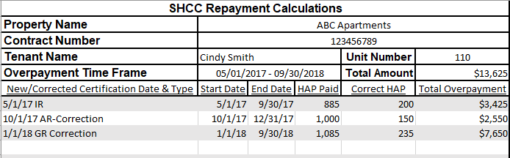

Example of the Adjustments to Schedule of Tenant Assistance Payments Due page:

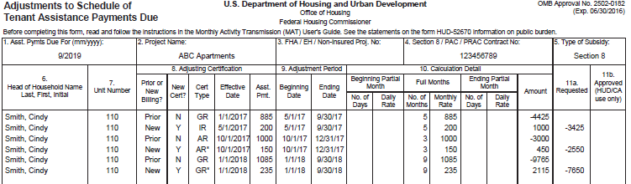

Example of the Repayment Agreements for Schedule of Tenant Assistance Payments Due page when setting the Repayment Agreement up:

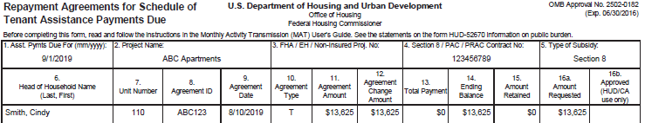

Example of the Repayment Agreements for Schedule of Tenant Assistance Payments Due page when the resident has made a payment:

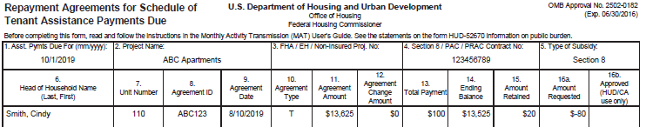

Links to Resources
HUD MAT User Guide: https://www.hud.gov/program_offices/housing/mfh/trx/trxdocs - Look in TRACS 202D Final Industry Specification Documents.
HUD Handbook 4350.3: https://www.hud.gov/program_offices/administration/hudclips/handbooks/hsgh/4350.3
Check out our website: http://www.shccnet.org/vouchers/

